St. George’s College Name: ____________________________

English Department Class: _____________________________

III Unit - 2016 Date: ______________________________

R. Bell/C. Greco/M.P. Muñoz

***Study Guide N°1:***

***Filling in the Holes***

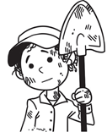

**Objectives:**

To create a traditional test consisting of literal questions, questions of inference, and evaluative questions.

To accurately create questions focusing on appropriate use of question words, word order, and punctuation.

To demonstrate reading comprehension of the novel Holes, by Louis Sachar.

**Time Allocation:** 10 classes of 45 minutes

**This guide will be worth 10 points of your overall Test Creation grade.**

Reading Comprehension

**Instructions:**

For every 10 chapters that you read, you will be required to answer a set of questions to ensure reading comprehension.

Requirements:

* The questions must be answered in complete sentences.
* The answers should have appropriate grammar, spelling, and punctuation.

**Section 1: Chapters 1🡪10 (_____/1 pt)**

1. Describe Camp Green Lake.

…………………………………………………………………………………………………………………………………………………………………………………………………………………………………………………………………………………………………………………………….

1. Why doesn't Camp Green Lake have fences?

…………………………………………………………………………………………………………………………………………………………………………………………………………………………………………………………………………………………………………………………….

1. What is the biggest rule in Camp Green Lake?

……………………………………………………………………………………………………………………………………………………………………………………………………………………………………………………………………………………………………………………………….

1. Why did the Yelnats’ apartment smell of foot odor and burning rubber?

………………………………………………………………………………………………………………………………………………………………………………………………………………………………………………………………………………………………………………………………

1. In chapter 9, how does Stanley almost get into a fight?

…………………………………………………………………………………………………………………………………………………………………………………………………………………………………………………………………………………………………………………………….

Keep going!

**Section 2: Chapters 11🡪 20 (_____/1 pt)**

1. Why do the boys always line up for water in the same order?

………………………………………………………………………………………………………………………………………………………………………………………………………………………………………………….

1. Why is Stanley happy that they call him Caveman?

…………………………………………………………………………………………………………………………………………………………………………………………………………………………………………………..

1. On page 58 Mr. Pendanski tells Stanley: “You messed up your life, and it’s up to you to ﬁx it.” Do you agree with this statement? Explain or give reasons.

……………………………………………………………………………………………………………………………………………………………………………………………………………………………………………………

1. Why does Stanley give the tube to X-Ray?

…………………………………………………………………………………………………………………………………………………………………………………………………………………………………………………..

1. How do the adults treat Zero? Give one example from the book.

…………………………………………………………………………………………………………………………………………………………………………………………………………………………………………………..

1. Give two examples of violence in chapter 17.

…………………………………………………………………………………………………………………………………………………………………………………………………………………………………………………..

1. After Zero confesses that he doesn’t know how to write. What’s Stanley’s reason to say no?

…………………………………………………………………………………………………………………………………………………………………………………………………………………………………………………..

1. Why does the warden strike Mr. Sir?

……………………………………………………………………………………………………………………………………………………………………………………………………………………………………………………

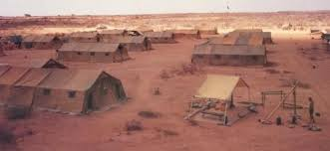

**Nicknames**

Most of the characters in this story hide behind nicknames. The names tell us something about them. Complete this table.

|  |  |  |
| --- | --- | --- |
| **Nickname** | **Real Name** | **How did the nickname arise?** |
| **Kissing Kate** |  |  |
| **X-Ray** |  |  |
| **Magnet** |  |  |
| **Mom** |  |  |
| **Trout** |  |  |

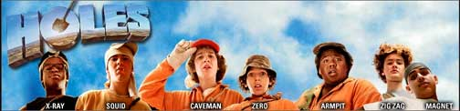

**http://www.classbrain.com/artmovies/uploads/holdes2-header.jpg**

**Chapters 21🡪 30 (_____/1 pt)**

1. Why does Zero dig Stanley’s hole after he goes to meet with the Warden?

…………………………………………………………………………………………………………………………………………………………………………………………………………………………………………………………………………………………………

1. Write two things that Stanley discovers about Zero in chapter 22.

………………………………………………………………………………………………………………………………………………………………………………………………………………………………………………………………………………………………….

1. Compare Katherine Barlow and Trout Walker in relation to the following aspects: education, money and kindness.

………………………………………………………………………………………………………………………………………………………………………………………………………………………………………………………………………………………………..

1. What does Hattie Parker scream at Sam and Katherine when she sees them kissing?

……………………………………………………………………………………………………………………………………………………………………………………………………………………………………………………………………………………………………

1. What does Stanley see when the lightning strikes in chapter 29?

………………………………………………………………………………………………………………………………………………………………………………………………………………………………………………………………………………………………….

1. The Warden wants to make it seem like Zero has just disappeared into the air. What does she want Mr. Pendanski to do?

…………………………………………………………………………………………………………………………………………………………………………………………………………………………………………………………………………………………………

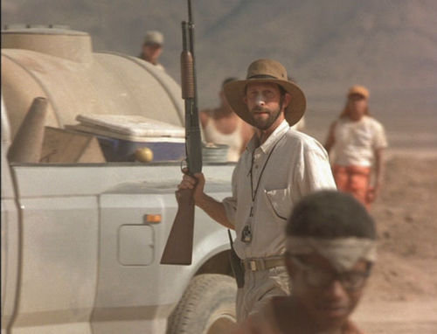

**http://vignette2.wikia.nocookie.net/disneyvillains/images/a/af/Dr._Pendanski.jpg/revision/latest?cb=20101030145901**

**Chapters 31🡪 40 (_____/1 pt)**

1. What are three things that make Stanley and Zero's trip difficult, requiring perseverance to overcome?

……………………………………………………………………………………………………………………………………………………………………………………………………

1. Who was hiding under the boat?

……………………………………………………………………………………………………………………………………………………………………………………………………

1. At the end of Chapter 34, Stanley sees a boat. What is its name? What else had that name, many years ago?

……………………………………………………………………………………………………………………………………………………………………………………………………

1. What did Stanley think that “sploosh” tasted like?

……………………………………………………………………………………………………………………………………………………………………………………………………

1. What are three things the shovel was used for in chapters 35 and 36? Draw or describe them.

……………………………………………………………………………………………………………………………………………………………………………………………………

1. What is so special about the onions that Zero and Stanley ate?

……………………………………………………………………………………………………………………………………………………………………………………………………

1. Name three objects from chapter 35 that re-appear after 100 years.

……………………………………………………………………………………………………………………………………………………………………………………………………

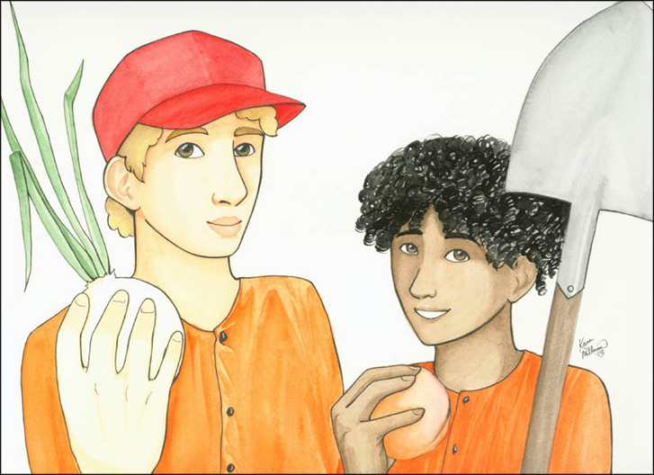

**https://tinasholesblog.files.wordpress.com/2015/03/kara-mb08.jpg**

**Chapters 41🡪 50 (_____/1 pt)**

1. What are Zero’s guidelines about stealing?

…………………………………………………………………………………………………………………………………………………………

1. What do we learn about Zero’s mother in chapter 41?

…………………………………………………………………………………………………………………………………………………………

1. Why did it start to rain when the kids left Camp Green Lake?

…………………………………………………………………………………………………………………………………………………………

1. What happened to Zero after he left Camp Green Lake?

…………………………………………………………………………………………………………………………………………………………

1. What is the treasure Zero and Stanley find?

…………………………………………………………………………………………………………………………………………………………



http://www.campaignercrm.com/a/i/uploads/burried_treasure-299x300.jpg

Questions

Literal Questions **(_____/1 pt)**

Literal questions have answers that can be found in the text. **The answers are directly stated** and the answers are located on the “surface” of the writing.

Examples: What is the main character's name? What is the most dangerous animal in Camp Green Lake?

How can you recognize them?

**Eventually everyone will agree with this answer.**

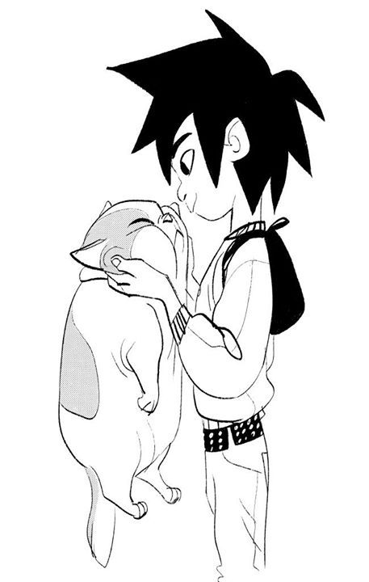**Exercise: What is the boy doing with the cat?**

________________________________________________________________________________________________________________________________________________________________________________________________

Does the cat look happy?

________________________________________________________________________________________________________________________________

Describe the physical appearance of the boy.

________________________________________________________________________________________________________________________________________________________________________________________________

(Hiro by Shiyoon Kim)

**Types of Literal Questions:**

Multiple Choice Questions: **(_____/1 pt)**

A multiple choice item consists of a problem, known as the **stem**, and a list of suggested solutions, known as alternatives. The alternatives consist of one correct or **best alternative**, which is the answer, and incorrect or inferior alternatives, known as distractors.

Example:

*What is the one big rule at Camp Green Lake? (stem)*

1. *Don't upset Mr. Sir (distractor)*
2. *Don't ask for water (distractor)*
3. *Don't run away (distractor)*
4. *Don't upset the Warden (Correct answer)*

Create **three literal multiple choice** questions, each with 4 alternatives:

**1**

**2**

**3**

True and False Questions: **(_____/1 pt)**

These are questions in which you write a statement and you ask the reader to decide whether it is true or not.

*Example:*

*Stanley was guilty of stealing the sneakers from Clyde Livingston. True/False*

Create three true and false questions based on the reading.

**1**

**2**

**3**

Matching Exercises:

In these questions we present alternatives and the student is supposed to connect them together. For example:

Match the following events in order of appearance with the numbers on the right:

1. Stanley arrives at Camp Green Lake 1
2. Stanley is given the nickname Caveman. 2
3. Stanley is sentenced to go to Camp Green Lake 3
4. Stanley digs his first hole. 4

Now it’s your turn! Create 1 matching exercise below:

Statement:_____________________________________________________________________________________________________________________________________

Options:

1. _______________________________________________ _________
2. _______________________________________________ _________
3. _______________________________________________ _________
4. _______________________________________________ _________

Fill in the blanks

These types of questions involve partial statements that students must complete with the correct answer.

*Example: The reason why there are no __________ (answer: fences) in Camp Green Lake is because anyone who escaped would die from dehydration.*

Create two fill in the blank questions:

**1**

**2**

Inferential Questions

The answers to inferential questions can be found in the text too, but they are implied, not directly stated. In other words, they are “between the lines” or under the surface.

*Example*

Let’s use the familiar story of The Three Little Pigs to illustrate this point.

**Passage:**

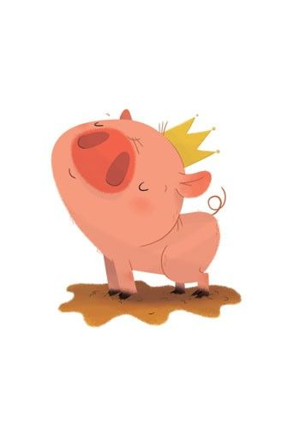The first pig built a house of straw while the second pig built his house with sticks. They wanted to build their houses very quickly so that they could go out and party. They sang, danced and ate all day because they were lazy. The third little pig worked hard all day and built his house with bricks.

**Question:** Why do you think the third pig built his house with bricks?

In this case, the clue to the answer would be that the third little pig worked hard all day. This implies that he was a hardworking pig.

So, a correct **answer** would be:

He was a hardworking pig.

Examples: Why do you think Stanley’s family blames their no-good-rotten-pig stealing-great-grandfather for their bad luck? (Pig by Ester Garay)

How can you recognize an inferential question?

* **They draw the reader into a deeper understanding of the text.**
* **The answers must be supported by the text.**

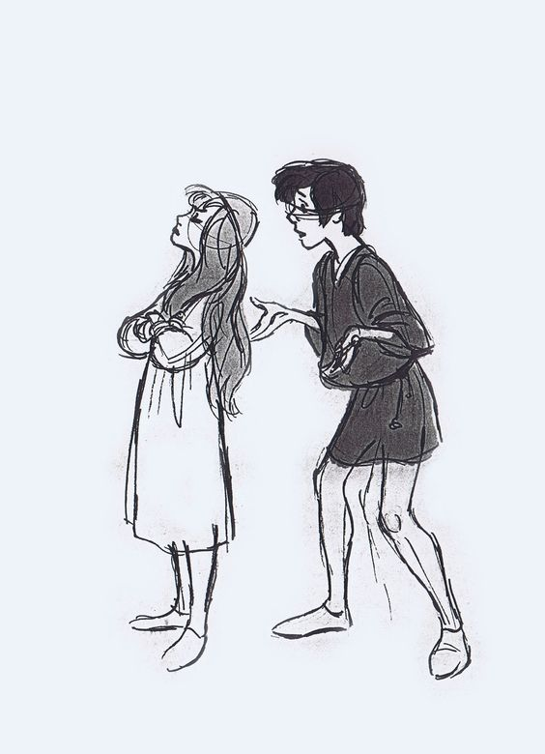Exercise:

What can you infer about the relationship between this girl and this boy?

________________________________________________________________________________________________________________________________________________________________________________________________________________________________________________________________________________________________

(The Black Couldron by Milt Kahl)

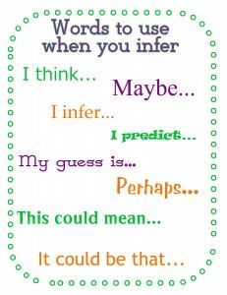

**Short answer questions:** **(_____/1 pt)**

These questions can usually be answered by writing 3-5 **complete sentences:**

*How is water an influential factor in Stanley’s life at Camp Green Lake?*

*Water is very important in Stanley’s life during his stay in Camp Green Lake because it’s very scarce. Since the campers are living in a desert, the possession of water is very important for their survival. Since the guards control the amount of water that the campers receive, they have a lot of control over their lives, so much so that they don’t even need to put a fence around the camp to prevent people from escaping.*

Exercises:

Create three short answer inferential questions.

1. Question:__________________________________________________________________________________________________________________________

Answer:______________________________________________________________________________________________________________________________________________________________________________________________________________________________________________________________________________________________________________________________

1. Question:__________________________________________________________________________________________________________________________

Answer:______________________________________________________________________________________________________________________________________________________________________________________________________________________________________________________________________________________________________________________________

1. Question:__________________________________________________________________________________________________________________________

Answer:______________________________________________________________________________________________________________________________________________________________________________________________________________________________________________________________________________________________________________________________

Evaluative Questions

The answers to evaluative questions require information from **outside of the text**. It involves your experience and ideas.

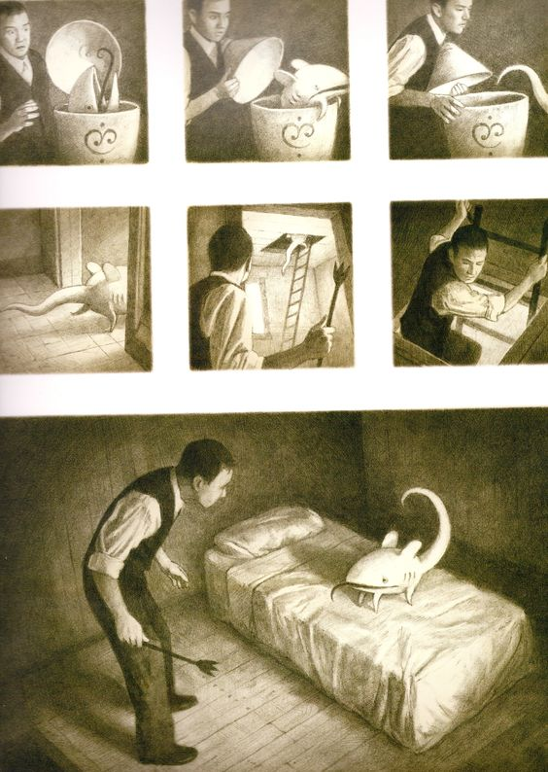*Examples:*

* *How are you similar to the main character?*
* *What was the author’s message in this book?*
* *Do any of the characters from Holes remind you of someone in your own life? Compare a person you know to a character in the book. How are they similar? How are they different?*

How can you recognize an evaluative question?

* This is the only type of question in which your personal opinion may be stated.
* In short, what do you think of some idea or theme presented in the work?

(*The Arrival* by Shaun Tan)

What kind of situation from real life does this image remind you of?

____________________________________________________________________________________________________________________________________________________________________________________________________________________________________________________________________________________________

**Essay Questions** **(_____/1 pt)**

Essay questions are different because they require more organized and in-depth thinking. An effective essay question will align with each of the following criteria:

* You **create** the answer; you do not select the answer from the book.
* It is a question that **makes you want** to write many sentences, not just one.
* A question that allows for many possible answers.

Examples:

*How are Stanley and Zero influenced by fate? In what ways do Stanley and Zero act in a way that shapes their own destiny?*

*How does cruelty shape a person’s personality? In what ways are the characters of Kissin’ Kate Barlow, Mr. Sir, and Zero shaped by the cruelty of others?*

Exercises:

1. Create an essay question **based on the theme of friendship**.

__________________________________________________________________________________________________________________________________

1. Create an essay question **based on the theme of family**.

__________________________________________________________________________________________________________________________________

**Review: Draw an “X” in the boxes below indicating which characteristics describe each kind of question. One type of question may fit in more than one category.**

|  |  |  |  |  |  |
| --- | --- | --- | --- | --- | --- |
|  | Closed Question (only one answer) | Open Question (many possible answers) | Literal  Question | Inferential Question | Evaluative Question |
| Multiple choice | X |  | X | X |  |
| Fill in the blank |  |  |  |  |  |
| Matching exercise |  |  |  |  |  |
| Short Answer |  |  |  |  |  |
| Essay |  |  |  |  |  |

**Now it’s your turn!**

**Test requirements—Format:**

1. Create **11 original questions/statements** based on the reading of **Holes.**
   1. 2 questions must be “Multiple Choice” type questions.
   2. 3 statements must be “True/False”.
   3. 1 statement must be “Fill in the Blank”
   4. 1 statement must be a “Matching Exercise”
   5. 3 questions must be “Short Answer” questions. These should be open questions that can be answered in 3-5 lines.
   6. 1 question must be an “Essay” type question.
2. Once you have created your questions, you must clearly identify them as either literal questions, inferential questions, or evaluative questions:
   1. At least 2 questions must be literal.
   2. At least 2 questions must be inferential.
   3. At least 2 questions must be evaluative.

**Self-Assessment**

Give yourselves a grade for participation, progress, and responsibility throughout these activities.

**The points go from 1 to 4, with point descriptions as follows:**

**4.** My behavior completely met the expectation. I will keep working hard!

**3.** My behavior met the expectation most of the time. I need to improve a little!

**2.** My behavior met the expectation some of the time. I need to improve!

1. My behavior did not meet the expectation.

|  |  |  |  |  |  |  |  |  |  |  |
| --- | --- | --- | --- | --- | --- | --- | --- | --- | --- | --- |
|  | **Day 1** | | **Day 2** | | **Day 3** | | **Day 4** | | **Day 5** | |
| **Expectation** | Self | Teacher | Self | Teacher | Self | Teacher | Self | Teachers | Self | Teacher |
| I come to class on time and I am ready to learn. |  |  |  |  |  |  |  |  |  |  |
| I bring all my materials to class. |  |  |  |  |  |  |  |  |  |  |
| I listen respectfully. |  |  |  |  |  |  |  |  |  |  |
| I work quietly and respectfully. |  |  |  |  |  |  |  |  |  |  |
| I use English in class all the time |  |  |  |  |  |  |  |  |  |  |
| I complete all assigned work. |  |  |  |  |  |  |  |  |  |  |